**RESTAURANT MANAGEMENT SYSTEM**

# A MINI PROJECT REPORT

Submitted By

SANJANA SHREE S – (220701245)

In partial fulfillment for the award of the degree of

BACHELOR OF ENGINEERING

IN

COMPUTER SCIENCE AND ENGINEERING

RAJALAKSHMI ENGINEERING COLLEGE (AUTONOMOUS) THANDALAM

CHENNAI-602105 2024-2025

**INDEX**

ABSTRACT …………………………………………………………3

INTRODUCTION ………………………………………………......4

1. OBJECTIVE
2. TARGET AUDIENCE
3. SCOPE

PROBLEM STATEMENT ………………………………………....6

SYSTEM REQUIREMENTS ……………………………………...7

TECH STACK AND TOOLS ……………………………………...7

BACKEND AND DATABASE DESIGN ………………………....8

USER INTERFACE (UI) ………………………………………….9

MODULES AND FUNCTIONALITIES ………………………...12

CHALLENGE AND FUTURE SCOPE ………………………….13

CONLUSION …………………………………………………….14

**ABSTRACT**

The Restaurant Management System (RMS) website is an integrated platform designed to optimize key restaurant operations, including table reservations, feedback collection, and menu management. The system enables customers to reserve tables online with real-time availability, reducing manual errors and improving convenience. It also features a structured feedback system, allowing diners to share their experiences and helping restaurants enhance service quality through actionable insights. Additionally, the dynamic menu management functionality ensures that customers have access to the latest offerings, which can be updated seamlessly. By combining these features, the RMS website aims to elevate customer satisfaction and streamline operational efficiency, offering a comprehensive solution for modern restaurant management.

**INTRODUCTION**

1. **OBJECTIVE**

The primary objective of the Restaurant Management System (RMS) is to create an integrated digital platform that streamlines key restaurant operations, including table reservations, feedback collection, and menu management. The system is designed to enhance the dining experience by enabling customers to reserve tables online with ease, providing real-time availability, and minimizing manual errors. Additionally, the feedback system encourages diners to share their experiences, empowering restaurants to improve their services using actionable insights. The dynamic menu management feature ensures that customers always have access to the latest offerings, fostering better communication between restaurants and their patrons. Overall, the RMS aims to boost customer satisfaction while improving operational efficiency for restaurants.

1. **TARGET AUDIENCE**

The Restaurant Management System is designed for restaurant owners, managers, and customers.

* Restaurant Owners/Managers: The platform provides tools to efficiently manage reservations, collect and analyze customer feedback, and update menus dynamically, saving time and reducing operational bottlenecks.
* Customers: It caters to diners who value convenience and efficiency, allowing them to make table reservations seamlessly, provide feedback to enhance restaurant services, and explore updated menus before their visit.

**iii. SCOPE**

The Restaurant Management System includes the following key features to ensure an efficient and engaging experience for both customers and restaurant staff:

**1. Online Table Reservations:**

Customers can view real-time availability and reserve tables online, reducing the need for manual booking processes and minimizing scheduling errors.

**2. Feedback Collection System:**

The platform allows diners to share their experiences through a structured feedback system. Restaurants can analyze this data to identify areas for improvement and make informed decisions to enhance service quality.

**3. Dynamic Menu Management:**

Restaurants can easily update their menus on the platform, ensuring customers always have access to the latest offerings, including daily specials or seasonal dishes.

**PROBLEM STATEMENT**

Restaurants face several challenges in their day-to-day operations, including managing reservations, handling customer feedback, and keeping menus updated. Relying on manual processes often leads to errors such as overbooked tables, missed reservations, or outdated menu details. These inefficiencies not only create operational challenges but also negatively impact the overall dining experience, leading to customer dissatisfaction.

From the customer's perspective, there is a growing demand for convenience and transparency. Customers want a simple and efficient way to reserve tables online, access the most up-to-date menus, and share their dining experiences through feedback. Without an effective system in place, restaurants miss the opportunity to improve their services based on customer input and fail to keep up with modern expectations for seamless digital interaction.

The Restaurant Management System (RMS) is designed to address these challenges. By providing a platform for online reservations, real-time feedback collection, and dynamic menu management, it enhances customer satisfaction and streamlines restaurant operations. This system bridges the gap between customer needs and restaurant efficiency, offering a complete solution for a better dining experience.

**SYSTEM REQUIREMENTS**

**Software Requirements**

* Programming Language: PHP for backend development and HTML, CSS, JavaScript for frontend design.
* Database: MySQL for managing structured data like orders, menus, and customer records.
* Web Server: XAMPP, which includes Apache for hosting the application and MySQL for database management.

**Hardware Requirements**

* Server: Minimum configuration server to manage:

(Customer orders, Real-time inventory updates)

* User Device: Desktop, tablet, or mobile device with internet connectivity for staff and customer use.

**TECH STACK**

**Backend**: PHP

* + *Justification*: Lightweight and easy-to-use server-side scripting language for dynamic content.

**Frontend:** HTML, CSS, and JavaScript.

* + *Justification*: Used for designing responsive and user-friendly interfaces.

**Database:** MySQL

* + *Justification*: Efficient for managing relational data such as customer details, orders, and menus.

**Web Server:** XAMPP

* + *Justification*: A bundled solution for Apache and MySQL that simplifies local hosting and development.

**BACKEND AND DATABASE DESIGN**

Database Structure

* Feedback Table: Handles storing and retrieving feedback from customers.
* Reservation Table: Manages reservation details for customers.

Feedback Table:

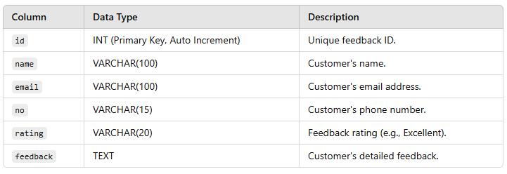

Reservation Table:

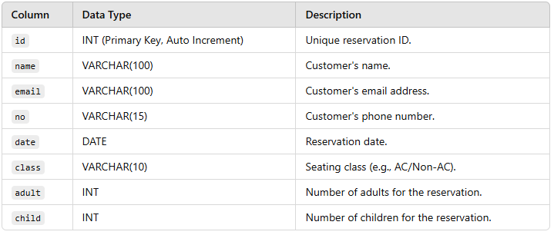

**USER INTERFACE**

HOME PAGE:

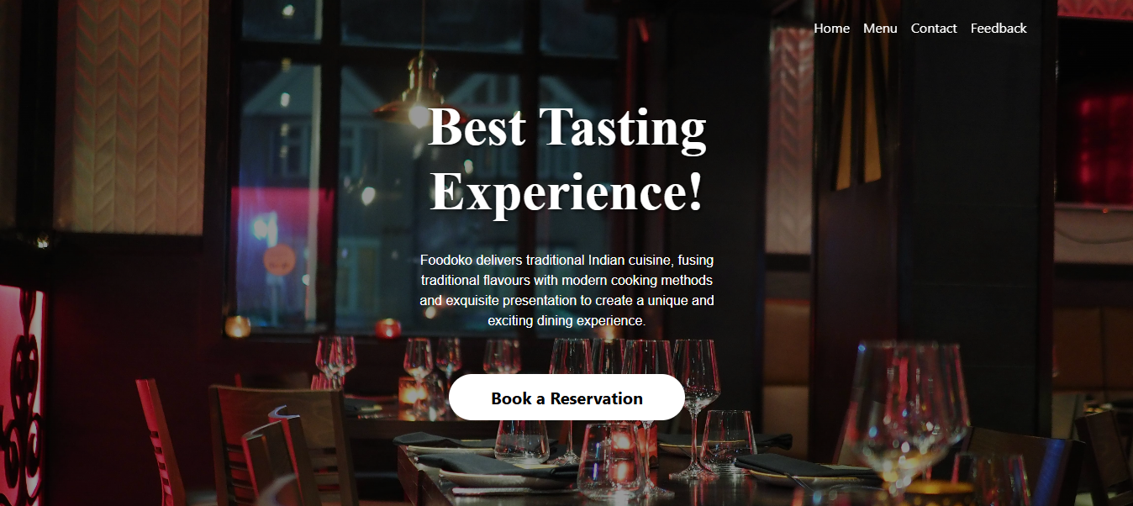

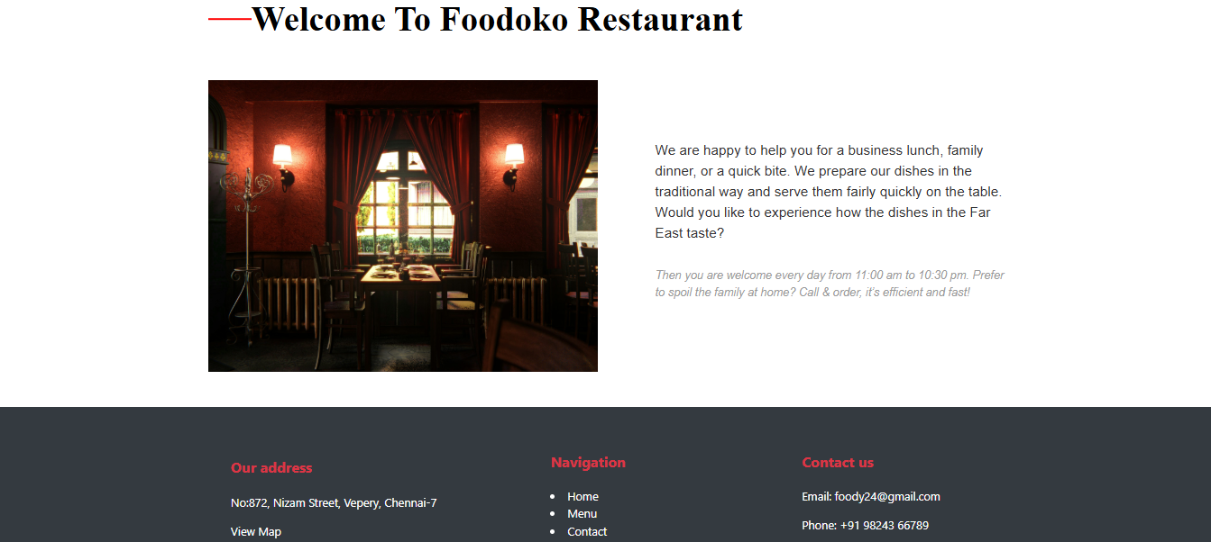

MENU PAGE:

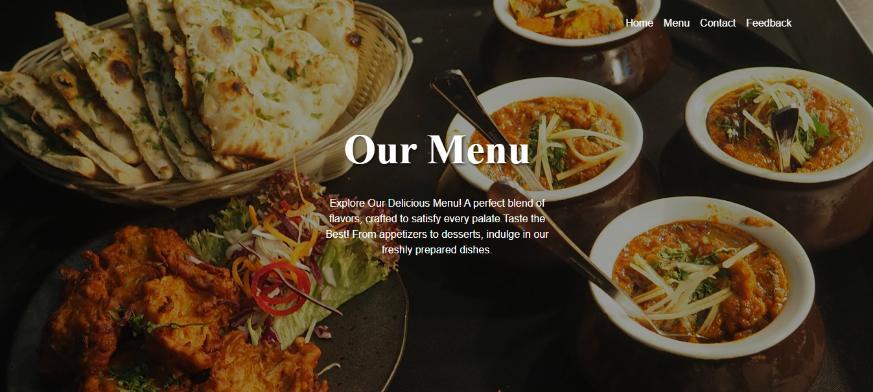

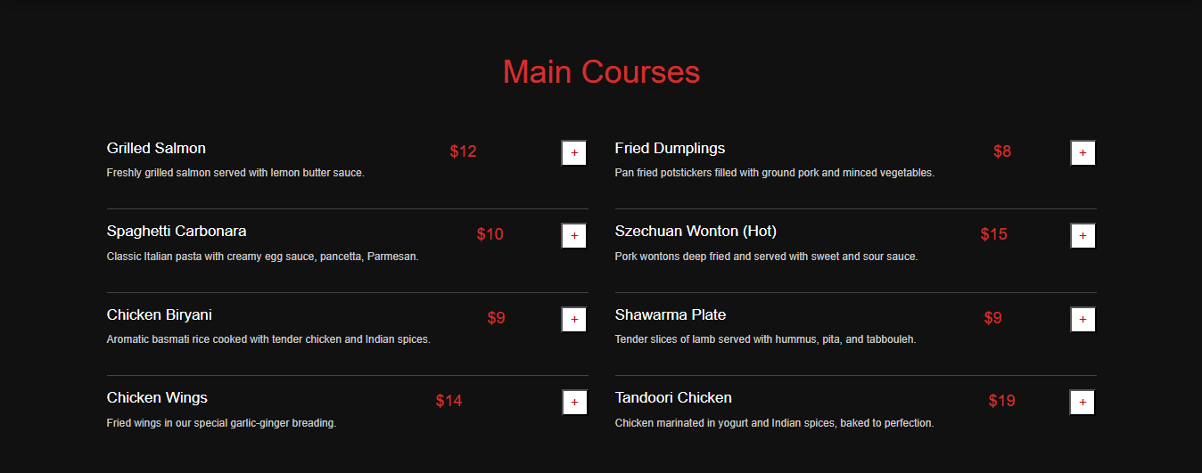

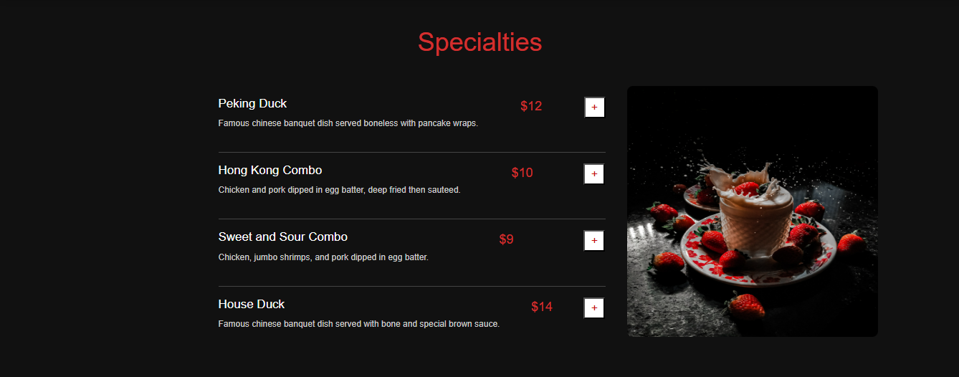

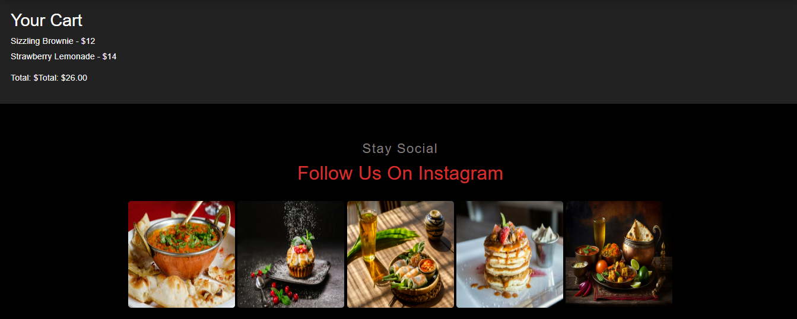

CONTACT PAGE:

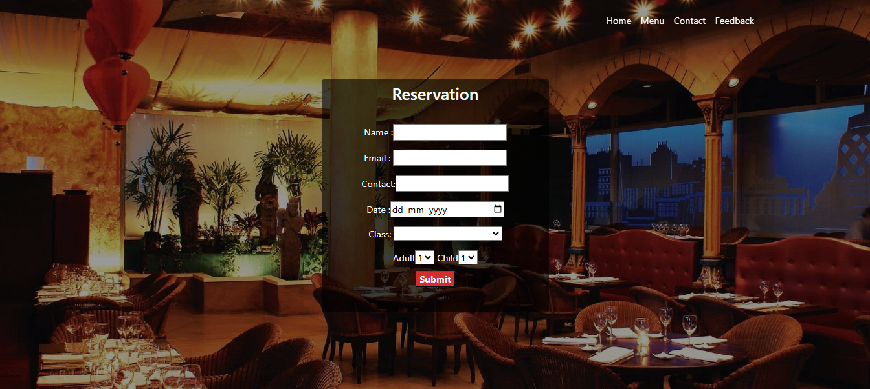

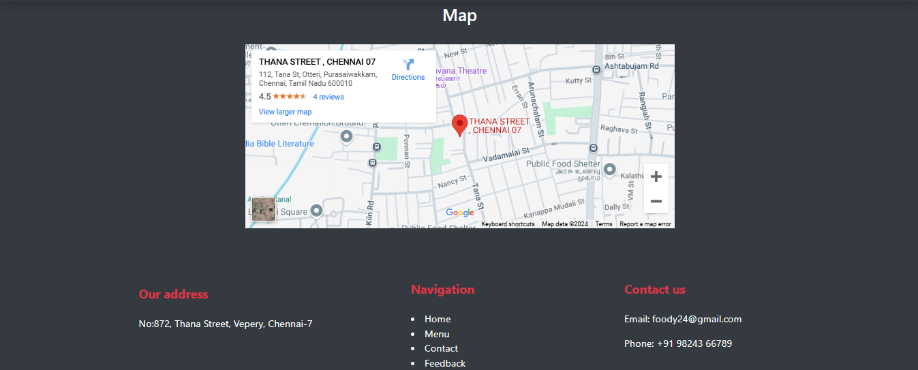

FEEDBACK PAGE:

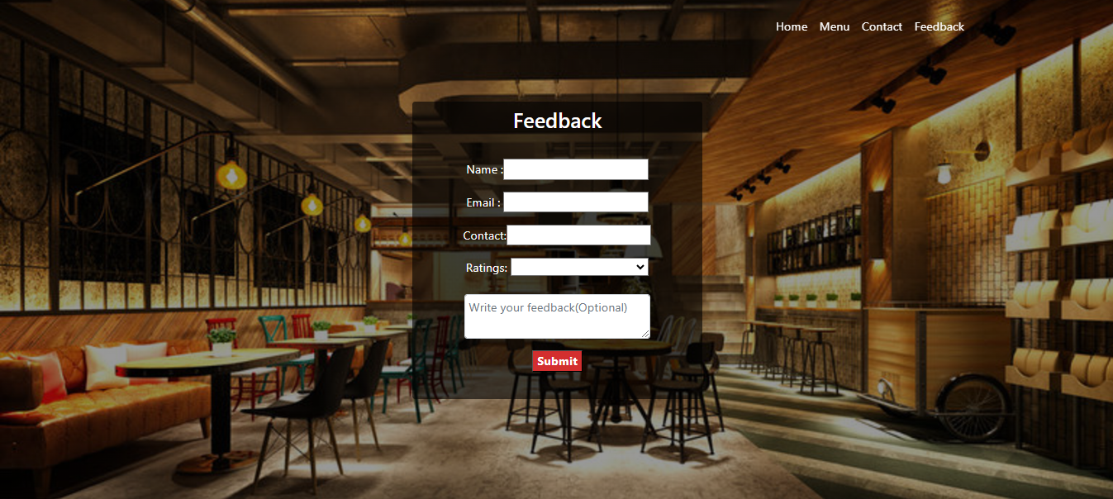

**MODULES AND FUNCTIONALITIES**

**1. Home Module**

* Welcome Message: A welcoming homepage with an introduction to the restaurant.
* Navigation: Easy access to other key sections (Menu, Reservation, Feedback).
* Contact Information: Include address, phone number.

**2. Menu Module**

* Menu Listings: Display a detailed list of food and beverage items, including descriptions and pricing.
* Categories: Organize the menu into categories (e.g., appetizers, main courses, desserts, drinks).
* Images and Descriptions: Include images and descriptions to help customers make informed choices.

**3. Reservation Module**

* Online Table Booking: Customers can select the date, time, and number of people for their reservation.
* Customer Details: Collect customer information (name, phone number, special requests) for the reservation.

**4. Feedback Module**

* Customer Reviews: Customers can provide feedback on their dining experience (star rating system).
* Comment Box: Allow customers to write detailed comments on their experience.

**CHALLENGES AND FUTURE SCOPE**

**Challenges:**

* Menu Management and Updates: Keeping the menu updated with new items, pricing changes can be a challenge.
* Customer Feedback Management: Collecting and analyzing customer feedback effectively can be time-consuming.
* Mobile Optimization: Ensuring that the website is mobile-friendly is essential, as a significant number of users will access the site from mobile devices, especially for making reservations or viewing the menu.
* Data Privacy and Security: Collecting personal information requires a high level of data security and adherence to privacy regulations.

**Future Scope:**

* Integration with External Platforms: Integrate with third-party platforms like Google Maps, OpenTable, or social media for enhanced functionality
* Personalized User Experience: By leveraging customer data and AI, the system could offer personalized recommendations
* AI-Powered Chatbot for Reservations and Feedback: Implement an AI-powered chatbot that can assist customers with making reservations, answering questions about the menu, or collecting feedback in real-time.
* Loyalty Program and Rewards System: Include a loyalty program, where returning customers earn points or discounts for reservations or feedback submissions.

**CONCLUSION**

The Restaurant Management System (RMS) offers a comprehensive solution for enhancing customer experience and streamlining restaurant operations. By focusing on key modules such as Home, Menu, Reservation, and Feedback, the system provides an intuitive and user-friendly platform that enables customers to easily make reservations, explore menus, and share their dining experiences. The integration of these features not only simplifies the management of day-to-day restaurant operations but also improves customer satisfaction through seamless interactions and real-time updates.

Despite the challenges in maintaining real-time reservation availability, managing a dynamic menu, and ensuring efficient feedback processing, these hurdles can be overcome with the right technology and system design. The future scope of the RMS suggests a path toward advanced personalization, better data analytics, and broader integration with external platforms, making it adaptable to the evolving needs of the restaurant industry.

As the system continues to develop, it holds the potential to revolutionize the dining experience for both customers and restaurant owners, driving operational efficiency, customer loyalty, and business growth. The Restaurant Management System is poised to be an essential tool in the modern restaurant's digital transformation.